BON DE LIVRAISON .
To place on your parcel ….

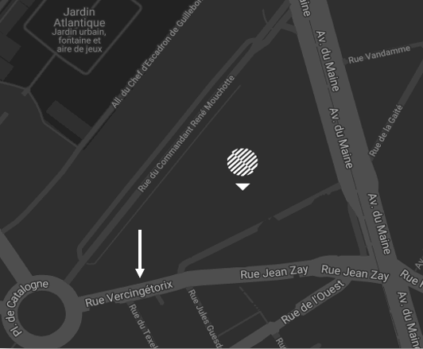
Delivery address PLAN D’ACCÈS
Quai de livraison – Pullman Paris Montparnasse

Département EVENTS - A l’attention de Charlotte Chapelain

12 rue vercingétorix 75014 Paris
: +33 (0) 1 44 36 43 43

No delivery will be accepted 24 hours prior the event for storage questions

NAME OF THE EVENR

DATE OF THE EVENT

NUMBER OF PARCEL (EX : 1/2)

(CONTACT ON SITE)

PHONE NUMBER of contact on site

